NetSuite

Netsuite overview

Oracle NetSuite ERP System is a comprehensive business management suite that offers a range of functionalities, including financial management, customer relationship management (CRM), e-commerce, and inventory management. It provides a unified platform for businesses to manage their operations efficiently.
History: Founded in 1998 as NetLedger by Evan Goldberg, with substantial backing from Oracle's Larry Ellison, the company initially offered web-hosted accounting software. Over time, it expanded its offerings to include a full suite of business applications beyond accounting, including ERP, CRM, and e-commerce. In 2016, Oracle Corporation acquired NetSuite for approximately $9.3 billion, integrating it into its cloud services portfolio.
Market Position: NetSuite has established itself as a leader in the cloud ERP space, serving over 37,000 customers across various industries worldwide. Its integrated cloud business system helps businesses simplify core processes, improve productivity, and grow more efficiently.
Competitors: Oracle NetSuite's main competitors include SAP, Microsoft Dynamics, and Infor. These companies also offer comprehensive ERP solutions, but Oracle NetSuite is often favored for its cloud-first approach and scalability.
Core Solutions: NetSuite provides a comprehensive suite of integrated, cloud-based applications that help businesses manage their core operations. Key modules include:
- Financial Management: Streamlines accounting processes and provides real-time visibility into financial performance.
- Customer Relationship Management (CRM): Offers a 360-degree view of customer interactions, enhancing sales and customer service efforts.
- E-commerce: Integrates online and in-store sales, providing a seamless omnichannel experience.
- Inventory and Supply Chain Management: Provides real-time tracking of inventory across various locations, ensuring efficient fulfillment.
- Human Capital Management (HCM): Manages employee records, performance, and payroll.
These modules are designed to work together, providing a unified platform for businesses to operate more effectively.
Strategy in Terms of Cloud Service Model: NetSuite operates on a Software as a Service (SaaS) model, delivering its ERP solutions entirely through the cloud. This approach offers several advantages:
- Accessibility: Users can access the system from anywhere with an internet connection.
- Scalability: The platform can easily scale with business growth, accommodating additional users and modules as needed.
- Automatic Updates: Regular updates ensure that all users have access to the latest features without manual intervention.
- Reduced IT Overhead: Eliminates the need for businesses to manage hardware or perform system maintenance.
Sustainable Development Goals (SDGs): While NetSuite's primary focus is on providing business management solutions, its cloud-based model contributes to sustainability in several ways:
- Resource Efficiency: By utilizing shared cloud infrastructure, it reduces the need for individual companies to maintain energy-intensive on-premises servers.
- Remote Accessibility: Facilitates remote work, potentially reducing commuting-related carbon emissions.
- Paperless Operations: Digital processes reduce the reliance on paper, contributing to environmental conservation efforts.

NetSuite Order MANAGEMENT
The Order Management solution from NetSuite is a complete cloud-based platform made to automate and optimize the order-to-cash procedure. Sales, finance, and fulfillment activities are integrated to guarantee precise and prompt order processing, improving customer satisfaction and organizational efficiency.
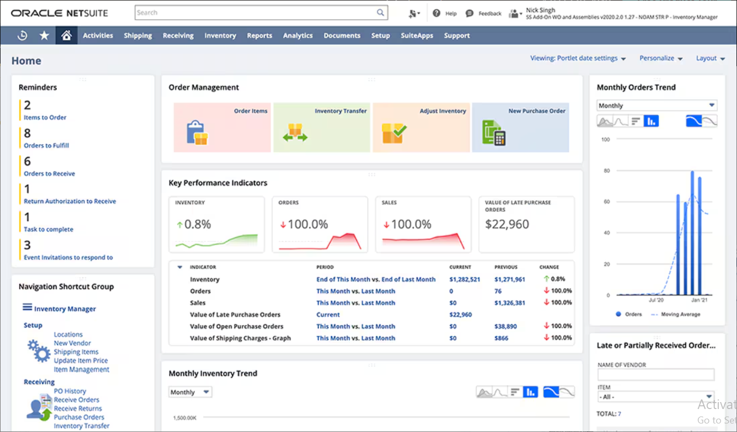Figure : Order Management Dashboard ^{[8]}
Key Features and Characteristics ^{[8]}:
- Centralized Order Processing: Using a single, cohesive system, NetSuite combines orders from many channels, including tele-sales, physical storefronts, and e-commerce platforms. Errors and processing time are decreased by centralizing the management of various order sources.
- Real-Time Inventory Management: Across several locations and sales channels, the platform provides real-time visibility into inventory levels. Businesses may successfully manage inventory, avoid stockouts or overstock scenarios, and make well-informed buying decisions thanks to this transparency.
- Automated Workflow Management: NetSuite streamlines important processes, including order fulfillment, billing, and approval. Businesses may guarantee consistent and effective order processing while reducing manual intervention and other bottlenecks by establishing clear rules and criteria.
- Integrated Financials: Order data enters accounting systems directly thanks to a smooth interaction with NetSuite's financial management modules. Accurate revenue recognition, invoicing, and financial reporting are made easier by this integration, which offers a comprehensive picture of the company's financial situation.
- Flexible Fulfillment Options: including drop shipping, direct shipment, and retail pickups, are supported by the solution. This adaptability improves service quality and operational agility by enabling companies to select the most economical and user-friendly fulfillment strategies.
- Customer Self-Service Portal: NetSuite provides a portal for customers to manage returns, track orders, and examine history. Providing self-service options to consumers not only enhances their experience but also lessens the workload for customer support representatives.
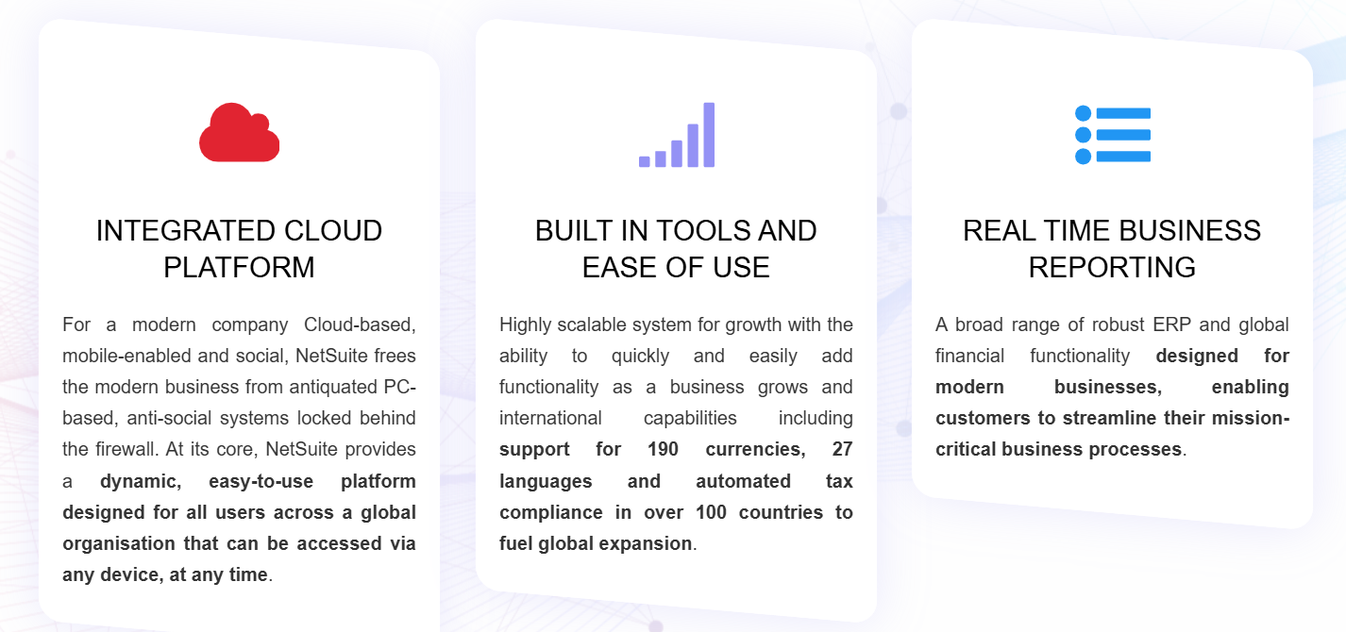
Advantages Contributing to Organizational Efficiency and Competitiveness ^{[8]}:
- Improved Accuracy and Decreased Errors: Automation reduces manual data entry, minimizing errors in order processing.
- Better Cash Flow: Companies can improve cash flow and lower days sales outstanding (DSO) by speeding up the order-to-cash cycle through streamlined procedures and integrated financials.
- Scalability: Because NetSuite's Order Management system is cloud-based, it can grow with your company without requiring large infrastructure investments. It can handle growing order volumes and expanding operations.
- Data-Driven Decision Making: Businesses can make well-informed decisions and quickly adjust to changes in the market thanks to real-time analytics and reporting that offer meaningful insights into sales trends, inventory turnover, and delivery success.

Netsuite in Manufacturing Sector
The manufacturing industry involves activities in which raw materials and components sourced from external suppliers undergo modification or assembly to enhance value. This process results in the creation of an inventory of finished goods subsequently transported downstream to distributors and ultimately to retailers, from which consumers purchase the goods.
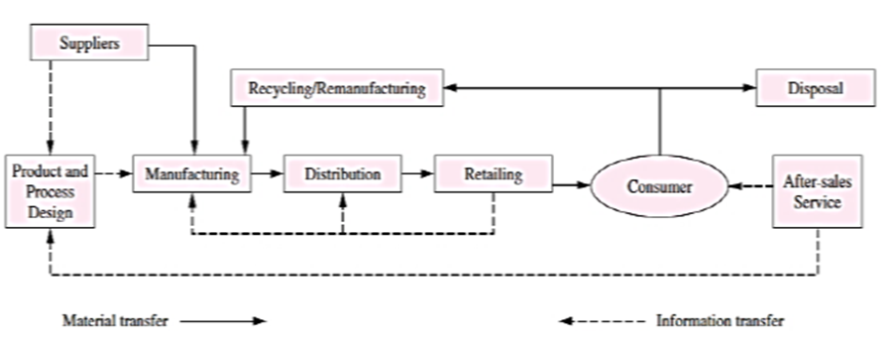
Figure 1: Supply Chain Flow ^{[1]}
Apart from the unidirectional flow as shown in the above diagram, the dotted line indicates information transfer, including operations conducted by suppliers, product and process design, and after-sales support, flowing from downstream to upstream. This information flow plays a significant role. For example, in after-sales service, manufacturers receive information or input regarding the advantages and disadvantages of product design. Sales data at retailer level can also be aggregated at the distributor level to prompt manufacturers to devise production schedules, mitigating inventory build-ups or shortages that can cause lost sales indicating that collaboration among suppliers, manufacturers, and customers allows companies to manage the flow of materials, products, and information effectively and efficiently. ^{[1]}
NetSuite Advanced Manufacturing is predominantly utilized in the manufacturing industry, encompassing both discrete and process manufacturing sectors. This comprehensive solution is designed to address the unique challenges faced by manufacturers, offering tools to enhance operational efficiency, reduce production costs, and integrate manufacturing processes with financial and inventory management systems.
- By integrating manufacturing operations with financial reporting and inventory management in real-time, NetSuite ensures seamless coordination across departments, reducing reliance on third-party applications.
- The solution offers robust planning and scheduling capabilities, enabling manufacturers to effectively manage shop floor activities, optimize capacity, and utilize resources efficiently, leading to lower operational costs.
- For discrete manufacturers, NetSuite provides an enhanced Manufacturing Work Bench that includes detailed operations routings, finite planning parameters, labour requirements, and configurable work order completion logic. Other additional features being the configurable Shop Floor Travelers (bar code enabled), Rough-Cut Capacity Planning, Dynamic Schedule Codes, Finite Production Scheduling, enhanced Work Order Release capabilities, supports full Manufacturing Execution System and Manufacturing Operations Management capabilities. Available to “OneWorld” customers.
- Process manufacturers benefit from features like recipe and formulation management, FIFO material issuance for lot-controlled items, and batch tracking with automatic lot identification, ensuring full traceability and control over materials.
- The platform supports mobile capabilities, including integrated barcode scanning and tablet functionality, allowing real-time reporting for work order completions, material issuance, downtime tracking, and labour or machine hours logging by employee ID.
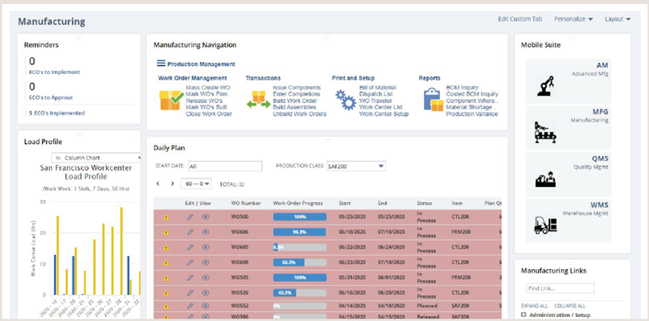
Figure 2: Advanced Manufacturing Centre ^{[2]}
NetSuite provides three deployment options to tailor its manufacturing functionality to different business needs. Additionally, if a company operates multiple manufacturing locations, it can choose to produce the same item using different methods at each site. The “Work Orders & Assemblies” module is best suited for businesses that perform light assembly and do not require tracking of work in progress (WIP) or labour separately. For companies needing more advanced capabilities, the “WIP & Routings” module enables the definition of work centres and routings, labour cost tracking, infinite capacity scheduling, and a Gantt chart with drag-and-drop functionality. For manufacturers seeking full control over their production processes, the “Advanced Manufacturing” module offers comprehensive features, including finite capacity scheduling and manufacturing execution, ensuring optimal efficiency and precision. ^{[2]}
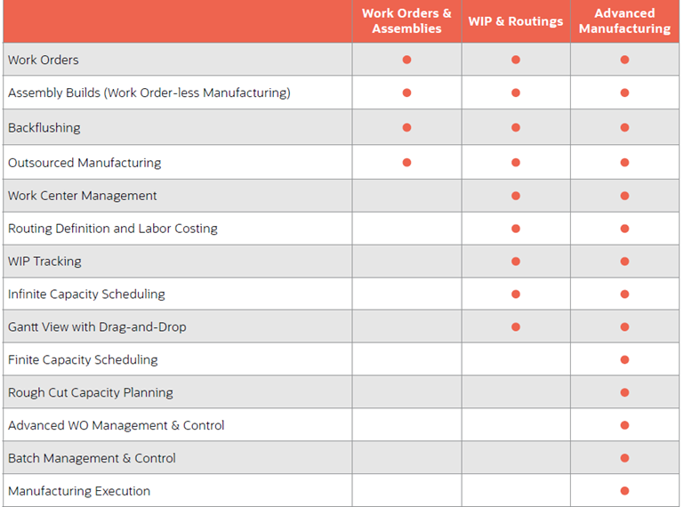
Figure 3: Models provided by NetSuite ^{[2]}

case study: PRO-FLEX's TRANSITION FROM EPICOR TO NETSUITE
Pro-Flex, a plumbing product supplier, implemented NetSuite as its order management solution after experiencing challenges with its legacy Epicor system. The previous system lacked visibility, leading to fragmented and outdated business data. It also had incomplete financial reporting and inventory tracking, requiring employees to rely on spreadsheets and manual calculations. ^{[9]}
Pro-Flex chose NetSuite for its cloud-based accessibility, real-time insights, and comprehensive ERP features. The system provided visibility into inventory, sales orders, and financials without delays. It also unified sales orders, work orders, and purchasing within a single platform, making operations more efficient and scalable for future business growth.
With NetSuite, Pro-Flex improved its order management by integrating orders, forecasts, and inventory into a single system. The Electronic Data Interchange (EDI) feature automated purchase orders and invoice processing, reducing manual workload. Custom orders were handled more efficiently through quick configuration of bills of materials. Enhanced forecasting capabilities allowed the company to optimize production schedules based on daily demand planning. ^{[9]}
Other manufacturing and distribution businesses have also adopted NetSuite for order management. Sioux Chief Manufacturing, a subsidiary of Pro-Flex, uses NetSuite to manage custom orders and streamline production. Many wholesalers and distributors handling large volumes of inventory across multiple locations have also benefited from NetSuite’s integrated supply chain management.
By switching to NetSuite, Pro-Flex transitioned from inefficient manual processes to a modern, scalable order management system. This case study highlights how businesses in manufacturing and distribution can improve efficiency, visibility, and decision-making through an integrated, real-time ERP solution.

Conclusion and Future Strategy
NetSuite has proven to be a powerful tool for businesses, helping them manage operations more effectively, improve decision-making, and support growth. While challenges like training, setup costs, and integration issues exist, the benefits of using NetSuite outweigh these difficulties. Companies that successfully implement NetSuite experience better efficiency, real-time data access, automation, and cost savings.
Looking to the future, NetSuite is expected to continue improving its cloud technology, automation, and artificial intelligence features. Businesses will benefit from more predictive analytics, AI-driven insights, and deeper integration with emerging technologies. As more industries move towards digital transformation, NetSuite is likely to introduce more specialized solutions tailored to different business needs.
Sustainability will also be a key focus, with cloud-based ERP solutions like NetSuite helping businesses reduce their carbon footprint by minimizing on-premise infrastructure. Additionally, with advancements in cybersecurity and data protection, NetSuite will remain a reliable and secure choice for businesses worldwide.
Overall, NetSuite will continue to play a major role in helping businesses stay competitive, adapt to market changes, and achieve long-term success.

REFERENCES

- Frost & Sullivan (2024). NetSuite awarded Frost & Sullivan’s 2024 Global Company of the Year Award for leading innovation in cloud business management solutions. Available at: https://www.frost.com/news/press-releases/netsuite-awarded-frost-sullivans-2024-global-company-of-the-year-award-for-leading-innovation-in-cloud-business-management-solutions/ [Accessed 9 Feb. 2025].
- 6sense (2024). NetSuite ERP market share and competitors. Available at: https://www.6sense.com/tech/erp/netsuite-erp-market-share [Accessed 9 Feb. 2025].
- NetSuite (n.d.). What is NetSuite? Available at: https://www.netsuite.com/portal/resource/articles/erp/what-is-netsuite.shtml [Accessed 9 Feb. 2025].
- KPC Team (2024). Exploring Oracle NetSuite ERP: A comprehensive overview. Available at: https://kpcteam.com/kpposts/exploring-oracle-netsuite-erp-a-comprehensive-overview [Accessed 9 Feb. 2025].
- Wikipedia (2024). NetSuite. Available at: https://en.wikipedia.org/wiki/NetSuite [Accessed 9 Feb. 2025].
- Fathoni, M.Z., Asih, A.M. and Wibisono, M.A. (2024) ‘Business process clustering in small and medium manufacturing industries based on Enterprise Resource Planning Concepts: A systematic literature review’, Management Systems in Production Engineering, 32(4), pp. 525–536. doi:10.2478/mspe-2024-0050.
- (No date) Netsuite Advanced Manufacturing. Available at: https://www.netsuite.com/portal/assets/pdf/ds-ns-advanced-manufacturing.pdf
- https://www.netsuite.com/portal/products/erp/order-management.shtml
- https://www.netsuite.com/portal/assets/pdf/wp-proflex-switching-from-epicor-to-netsuite.pdf

